Days of the Week
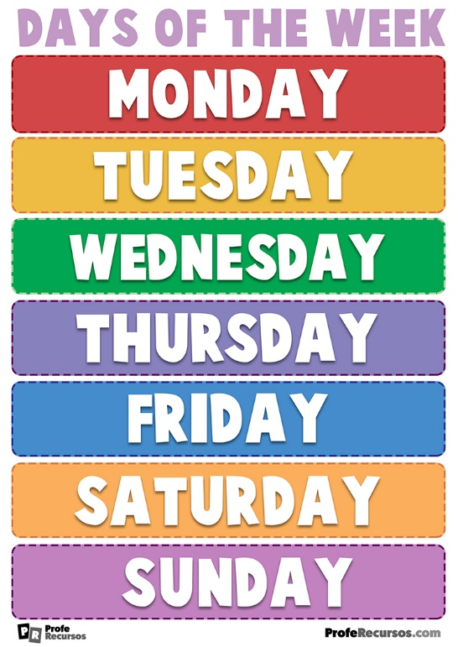
Months of the Year
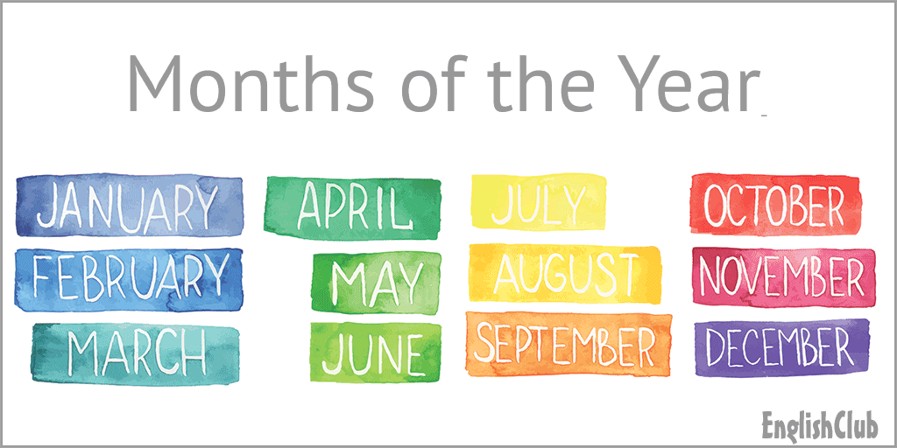

Ordinal Numbers
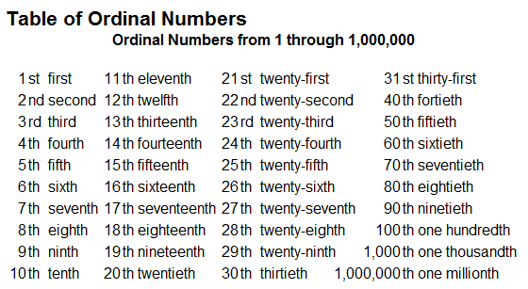
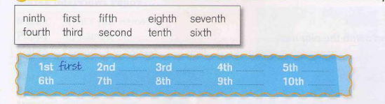
Dates
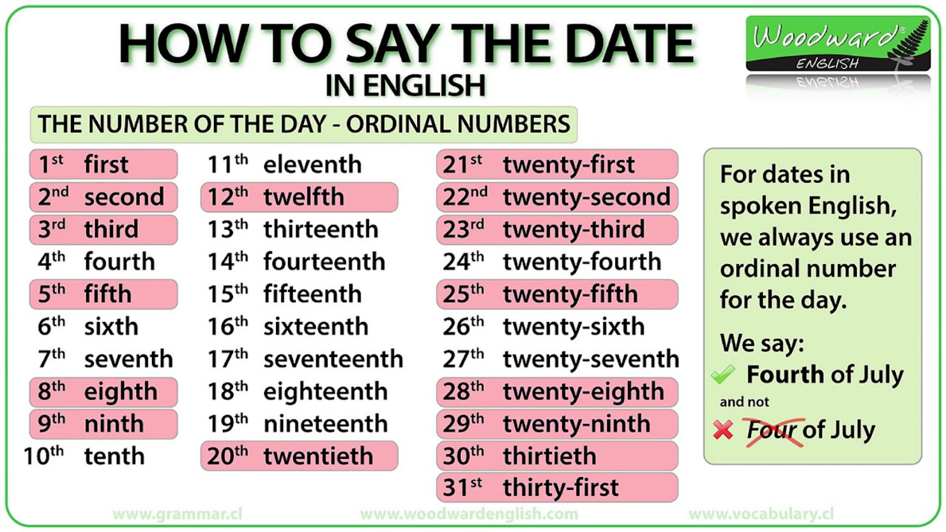
Vocabulary on Interests
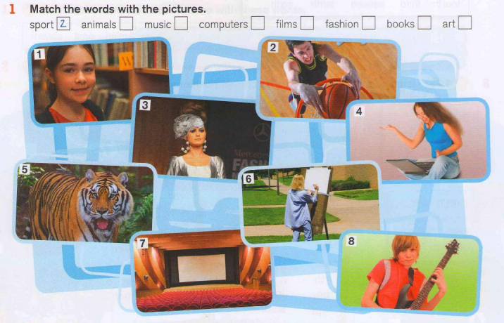
Factfile
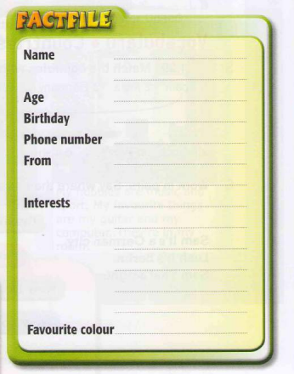
- My name is…
- I’m…
- My birthday is on…
- I’m from…
- My interests are…
- My favourite color is…

Questions

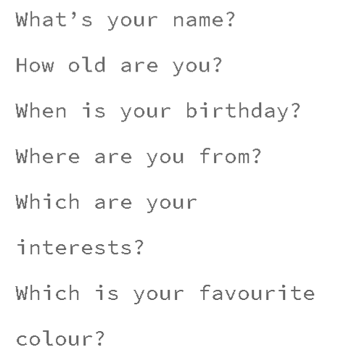

Countries and Nationalities
Activity: https://es.liveworksheets.com/worksheets/en/English_as_a_Second_Language_(ESL)/Countries_and_nationalities/Countries_and_nationalities_js800318ir
Activity: https://es.liveworksheets.com/worksheets/en/English_as_a_Second_Language_(ESL)/Countries_and_nationalities/Around_the_world_-_crossword_aj10395ss

Regular Plural Nouns
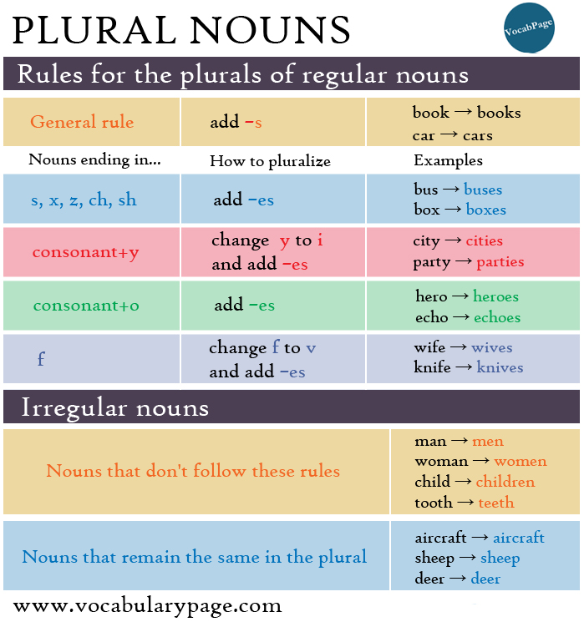
Activity: https://www.englishexercises.org/makeagame/viewgame.asp?id=8191

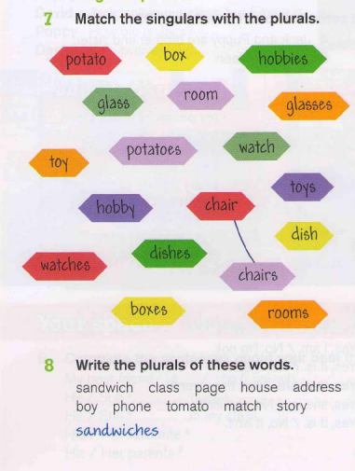
Possessive Forms
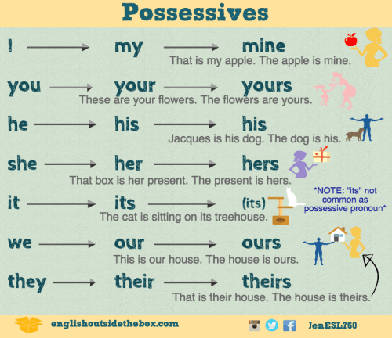
Activity: https://www.perfect-english-grammar.com/possessive-pronouns-and-possessive-adjectives-exercise-1.html

